**Power Query – World Population - Questions**

**DataSource1:** Connect to the following website and add to Power Query as query 1

<https://www.worldometers.info/world-population/population-by-country/>

Extract the population information from this site.

**DataSource2:** Connect to below excel and add to Power Query as query 2



***Note:***

* Dataset1 has both countries and dependent territories. But dataset2 mostly have countries. So, when you join you need to have only countries.
* Population data is from 2025, and happiness index report is from 2024(also few older years). That is not a problem.
* From the 2nd dataset take only the 2024 data for analysis and not all the Years.

Do the necessary cleaning and join the datasets.

1.Replacing values in columns (Yearly change, net change, Migrants): “ − “with “-“and “%” to type nothing > ok and “,” to nothing

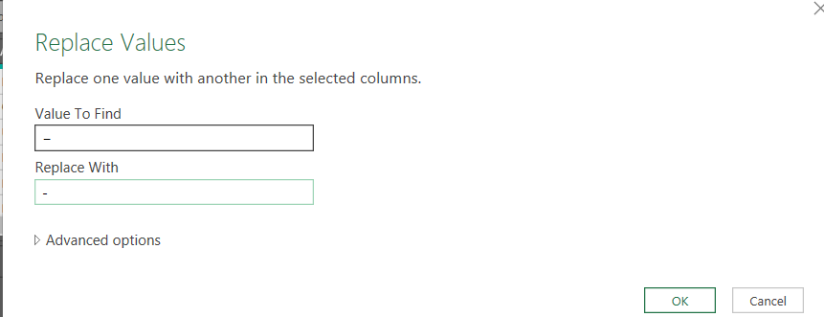

2.Change datatypes accordingly

3. I found below countries are same in both datasets but their names are different, so these countries happiness rank might miss when you join. Two happiness dataset countries are not in population countryNames

Replace below values in happiness dataset and then join. To get ranks for these countries too.

|  |  |
| --- | --- |
| **HappinessCountryNames** | **PopulationCountryNames** |
| Czechia | Czech Republic (Czechia) |
| Taiwan Province of China | Taiwan |
| Kosovo | not found |
| Viet Nam | Vietnam |
| Republic of Korea | South Korea |
| Russian Federation | Russia |
| Republic of Moldova | Moldova |
| Hong Kong SAR of China | Hong Kong |
| Lao PDR | Laos |
| Türkiye | Turkey |
| Côte d’Ivoire | not found |

To find above contries

Merge population dataset and happiness dataset with full outer join

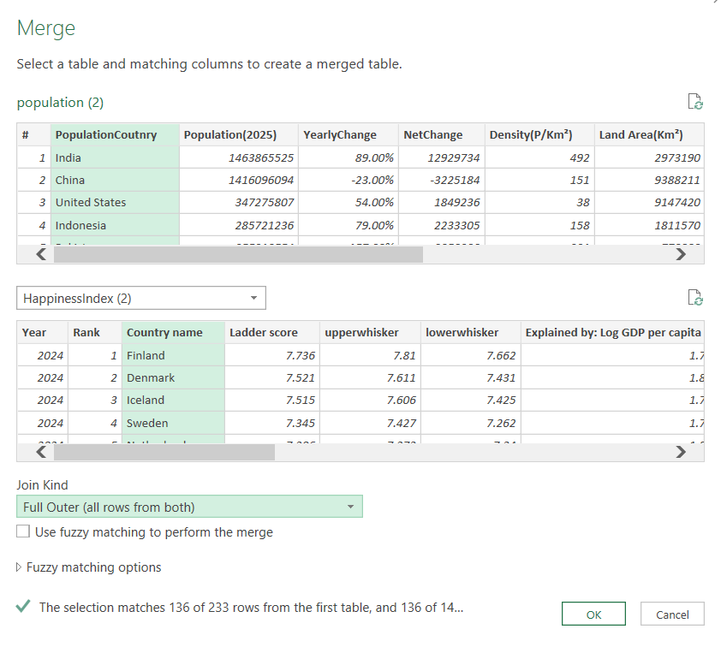

Select the table column and select these columns > ok

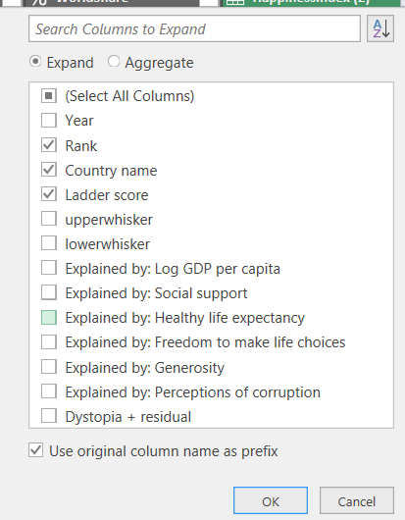

We can see some countries like Russia, Vietnam, turkey got null so

To find countries from the happiness dataset that are not in the population dataset, using a custom column in Power Query, use this formula:

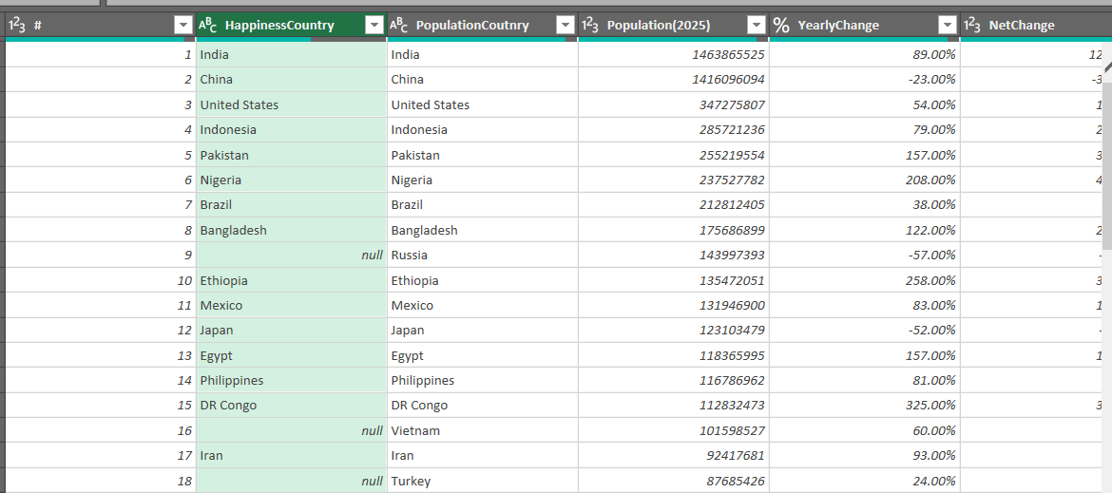

Name your country columns correctly

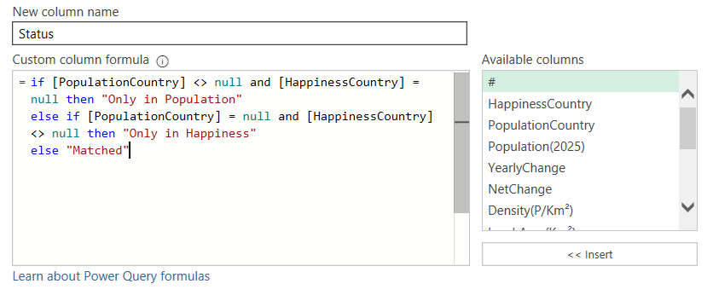

You will see a column with below rows so filter them

Filter **only in happiness**

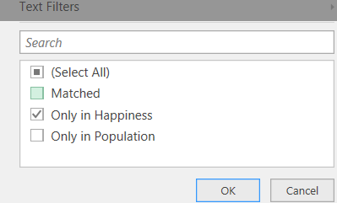

You will see below

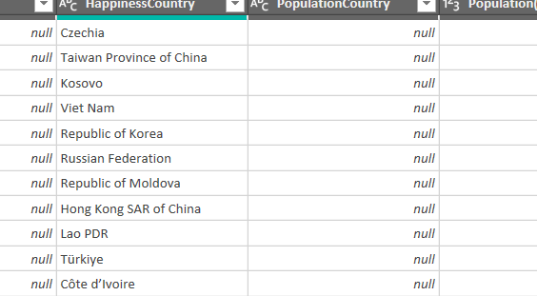

Replace these values with above table values in happiness dataset.

Ignore “cote d ivore” and “Kosovo” countries

**#You can do this in many ways**

I duplicated the tables and did the process on population (2) and happinessIndex(2)

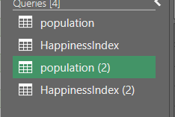

After replacing all values in happinessIndex table country column, you can go for merging with **left outer join**

Now using information from both the files, analyze and answer the questions below using Power Query:

1. Which 3 countries have the highest population?

Select the population column and then sort it descending

Home > keep rows> keep top rows > 3 >ok

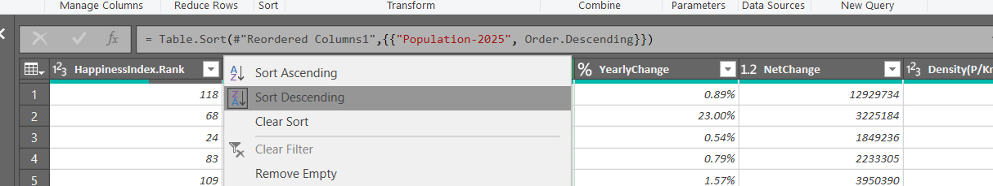

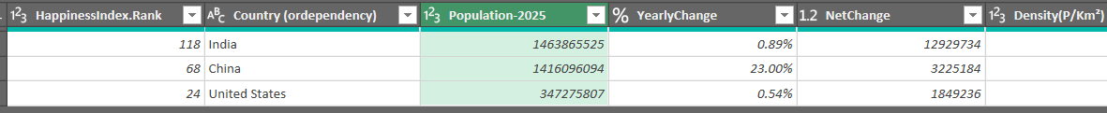

1. Which 3 countries have the highest happiness index?

Select the HappinessRank column which was merged from dataset2 > sort ascending

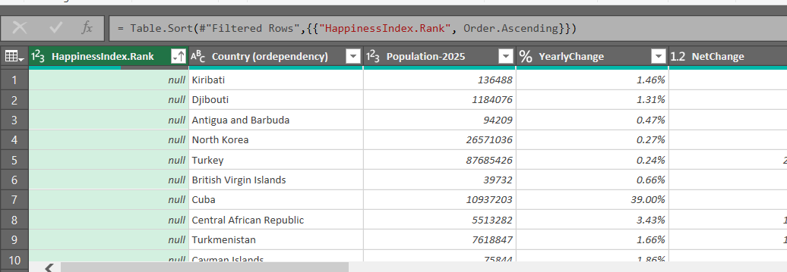

Filter out null values

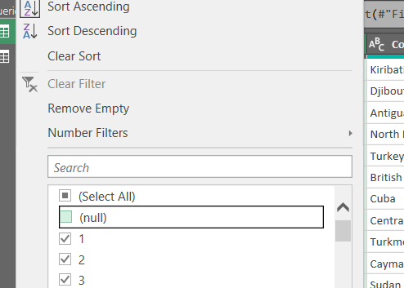



1. What is the total population of all the countries together?

Select Population column > Transform > statistics > sum >

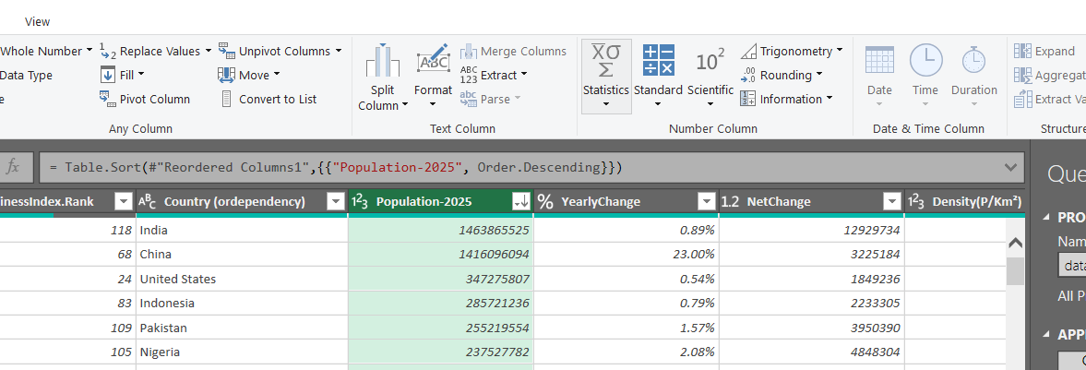



1. What is the corresponding population of top 5 countries who have the highest happiness index?

Select Happinessindex rank column > filter 1,2,3,4,5 ranks > select population column > transform > statistics > sum

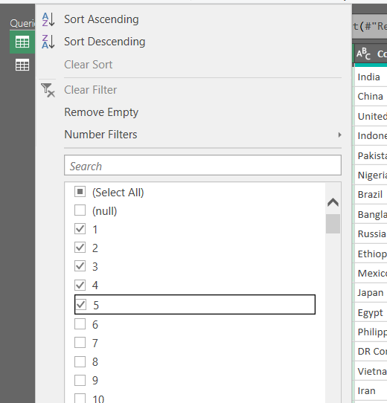

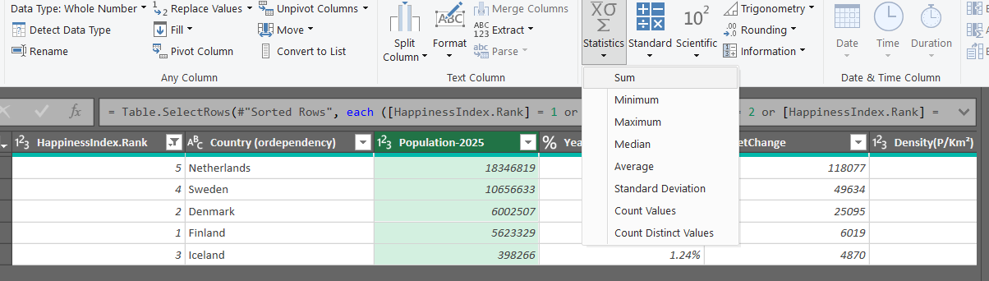



1. What is the range of median age of top 5 countries with the highest happiness index?

Range = max - min

For this filter top 5 ranks >

Add custom column > = List.Max(#"Previous Step"[Median Age]) - List.Min(#"Previous Step"[Median Age])

“**Previous step**” in the formula is the last applied step name of your applied steps

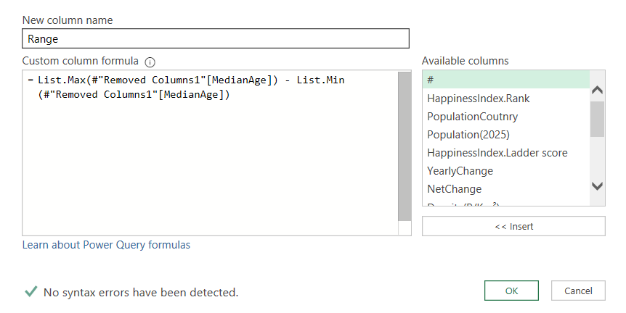

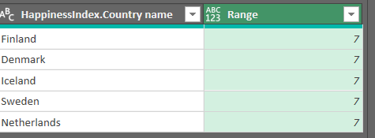

1. Which countries are growing Year-on-Year by more than 1%?

Select yearlychange column > go to Filter drop down > numberfilters > give 0.01 > ok

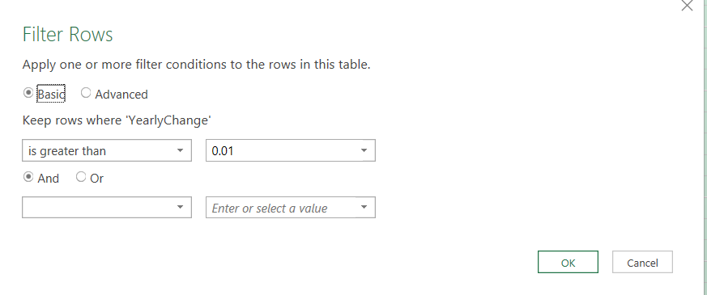

As per my columns 1% mean = 0.01

Ans:105 countries

Pakistan,Nigeria,Bangladesh,Ethiopia,Egypt,DR Congo,Tanzania,South Africa,Kenya,Colombia,Sudan,Uganda,Algeria,Iraq,Afghanistan,Yemen,Angola,Ukraine,Uzbekistan,Malaysia,Ghana,Mozambique,Peru,Saudi Arabia,Madagascar,Côte d'Ivoire,Cameroon,Niger,Mali,Syria,Burkina Faso,Zambia,Malawi,Chad,Kazakhstan,Somalia,Senegal,Guatemala,Cambodia,Zimbabwe,Benin,Rwanda,Guinea,Burundi,South Sudan,Bolivia,Haiti,United Arab Emirates,Tajikistan,Honduras,Papua New Guinea,Israel,Togo,Sierra Leone,Laos,Turkmenistan,Libya,Kyrgyzstan,Paraguay,Nicaragua,Congo,Liberia,State of Palestine,Oman,Central African Republic,Mauritania,Ireland,Kuwait,Panama,Eritrea,Mongolia,Qatar,Namibia,Gambia,Gabon,Botswana,Lesotho,Guinea-Bissau,Equatorial Guinea,Bahrain,Timor-Leste,Eswatini,Djibouti,Comoros,Solomon Islands,Luxembourg,Western Sahara,Malta,Belize,Iceland,Mayotte,Vanuatu,French Guiana,Sao Tome & Principe,Kiribati,Seychelles,Andorra,Cayman Islands,Faeroe Islands,Sint Maarten,Gibraltar,Caribbean Netherlands,Saint Barthelemy,Tokelau,Holy See

1. What are the top 3 countries with highest population density?

Select Density column > sort descending > keep rows > 3 > ok



1. What is the projected population for each country by 2026 considering the current Year-on-Year change %?

Ans: Projected population formula = current population * (1+yearly change in decimals)

Create custom column > enter this formula as per your columns

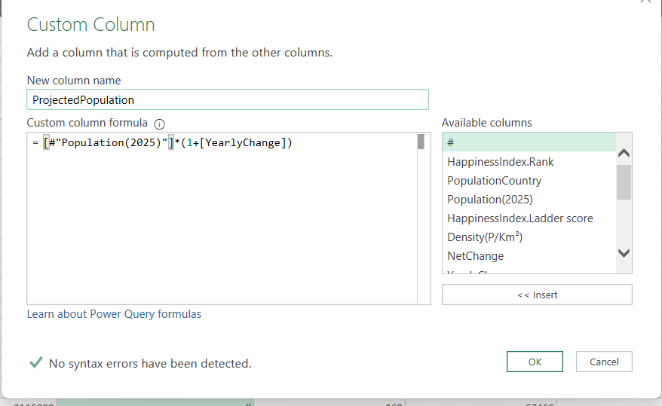

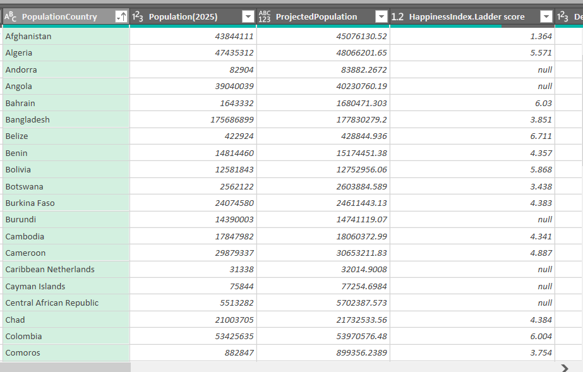

Total population for current year



Total projected population for 2026



1. How many countries have both fertility rate between 1 to 1.5 and density above 500?

Ans: 7

Select fertility column > Filter drop down > number filters > between > 1 and 1.5 > ok

Select density column > Filter drop down > number filters > greater than> 500

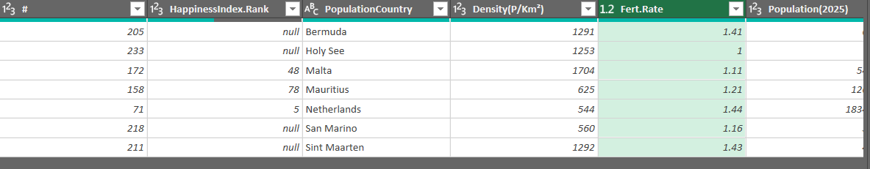

1. Which countries have a drop in population?

Select yearly change column > Filter drop down > number filter > less than >

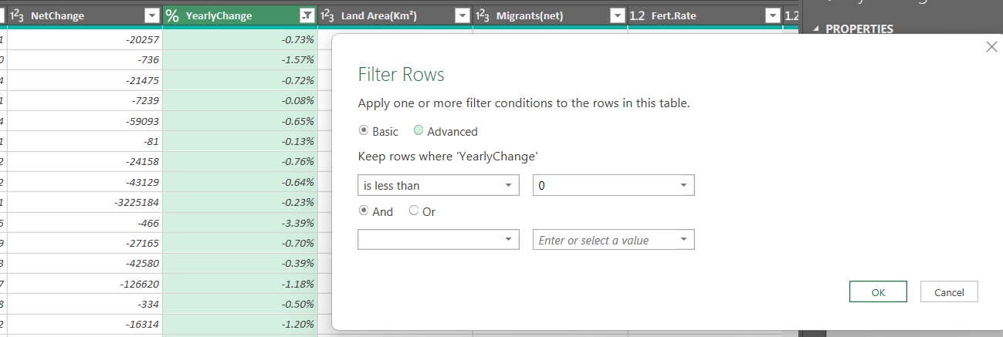

Total countries = 62

Albania,American Samoa,Armenia,Austria,Belarus,Bermuda,Bosnia and Herzegovina,Bulgaria,China,Cook Islands,Croatia,Cuba,Czech Republic (Czechia),Dominica,Estonia,Falkland Islands,Georgia,Germany,Greece,Greenland,Guadeloupe,Hong Kong,Hungary,Isle of Man,Italy,Jamaica,Japan,Jordan,Latvia,Lithuania,Marshall Islands,Martinique,Mauritius,Moldova,Monaco,Montenegro,Montserrat,Nepal,North Macedonia,Northern Mariana Islands,Palau,Poland,Portugal,Puerto Rico,Romania,Russia,Saint Helena,Saint Pierre & Miquelon,San Marino,Serbia,Slovakia,Slovenia,South Korea,Spain,St. Vincent & Grenadines,Taiwan,Thailand,Tonga,Tuvalu,U.S. Virgin Islands,Uruguay,Wallis & Futuna

1. How many countries are there between the population range of 100 million to 1 billion?

Select population column > filter drop down > number filters > between >

Enter **100,000,000** and **1,000,000,000**

Ans : 14 countries

1. Among the top 100 highly populated countries, how many of them have happiness index among the top 10?

Ans:4 countries

Select population column > sort descending > keep rows > 100

Select happiness index rank column > filter drop down >number filters > less than equal to = 10 > ok

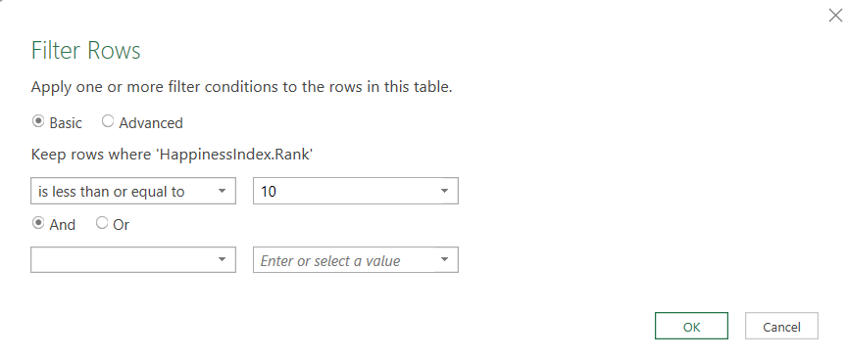



1. Which countries have a median age above 30 and below 45?

Ans: 109 countries

China, United States, Indonesia, Brazil, Russia, Vietnam, Iran, Turkey, Thailand, United Kingdom, France, Myanmar, Colombia, Argentina, Canada, Ukraine, Poland, Malaysia, Peru, Australia, North Korea, Sri Lanka, Taiwan, Chile, Romania, Netherlands, Tunisia, Belgium, United Arab Emirates, Cuba, Sweden, Czech Republic (Czechia), Azerbaijan, Hungary, Austria, Belarus, Switzerland, Bulgaria, Serbia, Denmark, Singapore, Finland, Norway, Slovakia, Ireland, New Zealand, Costa Rica, Kuwait, Panama, Georgia, Uruguay, Qatar, Moldova, Armenia, Jamaica, Lithuania, Albania, Slovenia, Latvia, North Macedonia, Bahrain, Trinidad and Tobago, Cyprus, Estonia, Mauritius, Réunion, Bhutan, Macao, Luxembourg, Montenegro, Western Sahara, Malta, Maldives, Brunei, Bahamas, Iceland, New Caledonia, Barbados, French Polynesia, Curaçao, Saint Lucia, Guam, Seychelles, Grenada, Aruba, St. Vincent & Grenadines, Antigua and Barbuda, U.S. Virgin Islands, Andorra, Cayman Islands, Dominica, Faeroe Islands, Greenland, Saint Kitts & Nevis, Turks and Caicos, Sint Maarten, Northern Mariana Islands, Liechtenstein, Gibraltar, British Virgin Islands, Caribbean Netherlands, Palau, Anguilla, Cook Islands, Saint Barthelemy, Wallis & Futuna, Montserrat, Falkland Islands, Niue

Select > medianage column > filter drop down > number filter > between > advanced > operator greater than and is less than

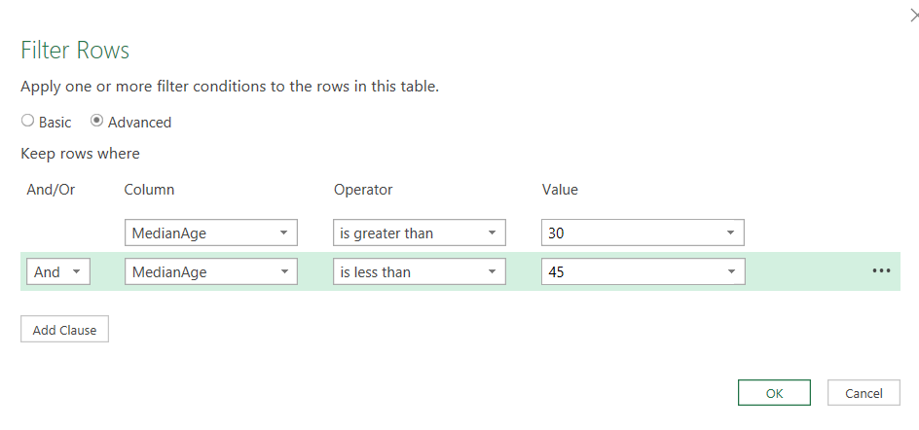

1. Arrange the countries in order of their decreasing density and which country has the 5th and 20th highest density? (List both the countries)

Select density column > sort descending > add column > index column > from 1

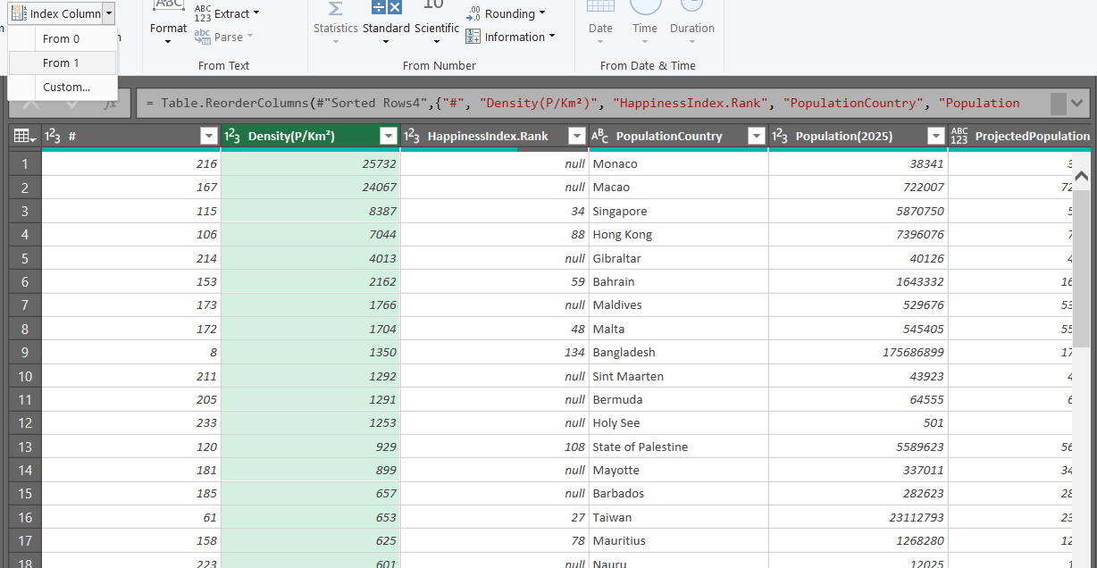

Select Index column > filter drop down > unselect all > select 5, 20

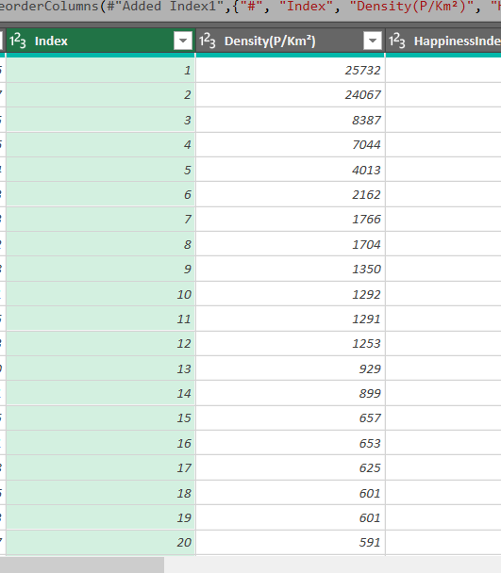

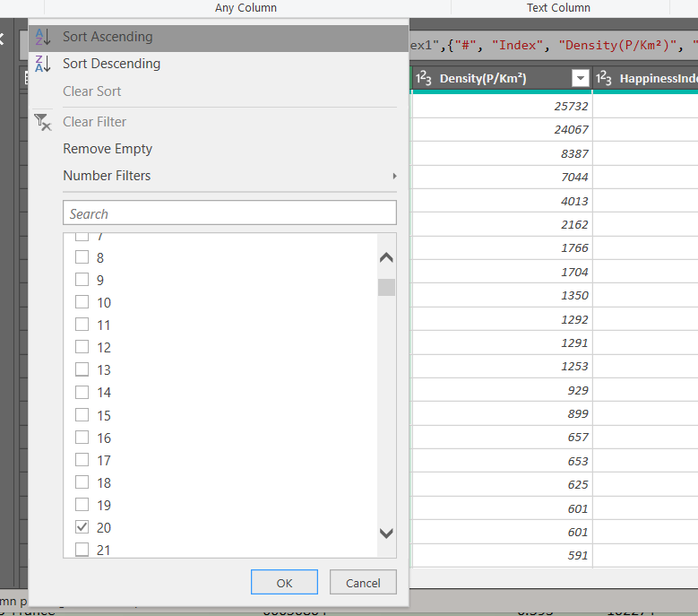

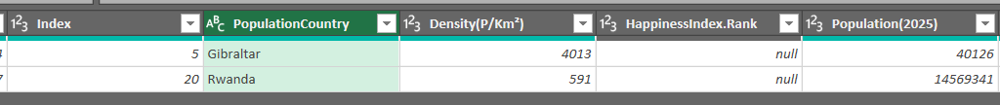

1. What % of the Total population does south Asian countries like India, Pakistan, Bangladesh contribute to?

Ans: 23.02%

Select custom column > Calculate total population

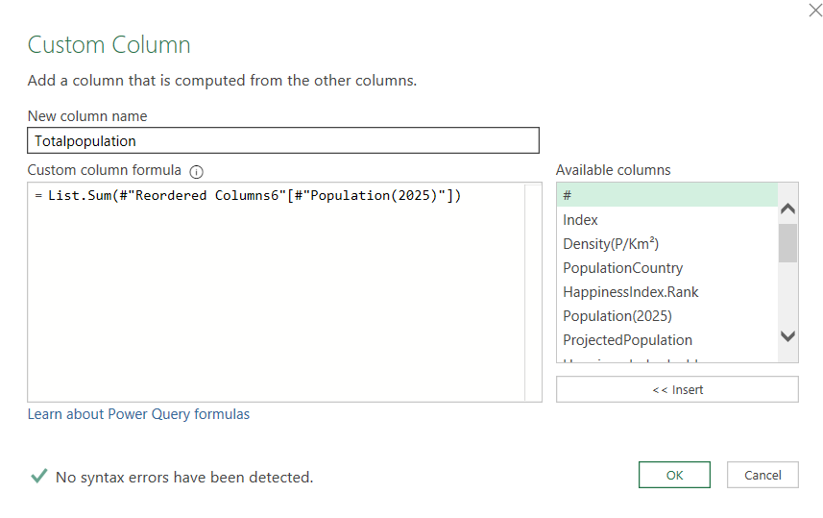

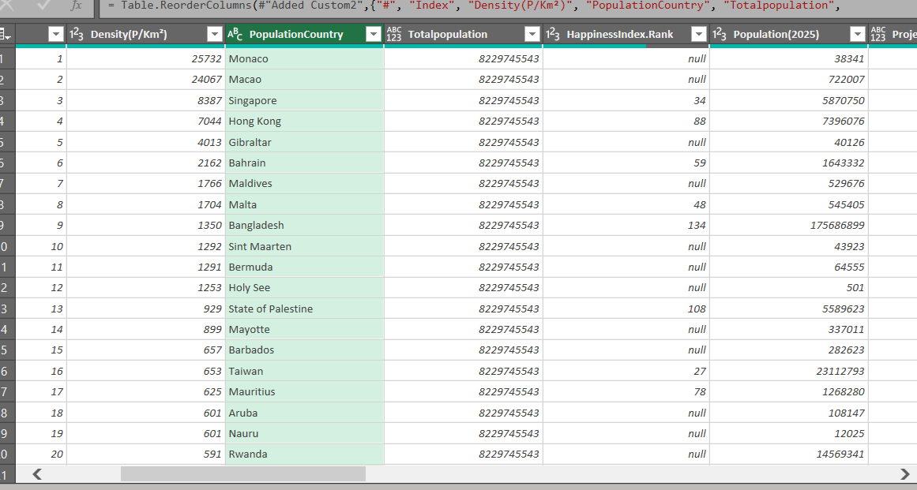

Select country column > filter drop down > select India, pakistan, bangldesh > ok

Add a custom column

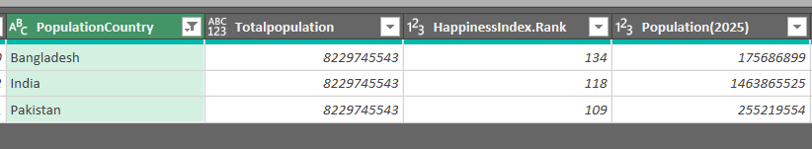

That arrow pointed is the previous step name of applied step located right side of power query

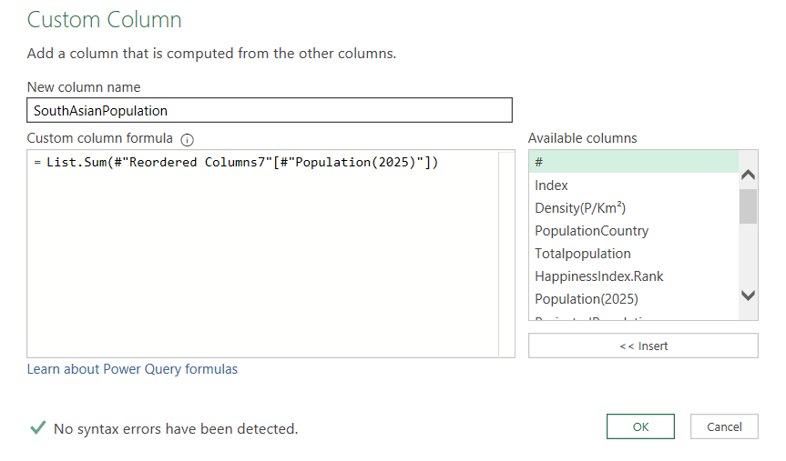

For more readabilty do below

Select these columns and remove other columns

Then keep 1 row

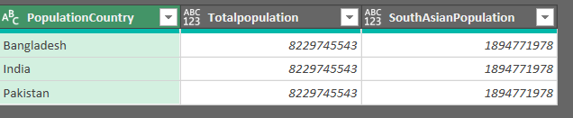

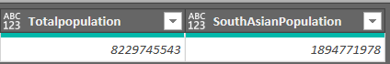

Add custom column > totalpopulation / southasianpopulation *100

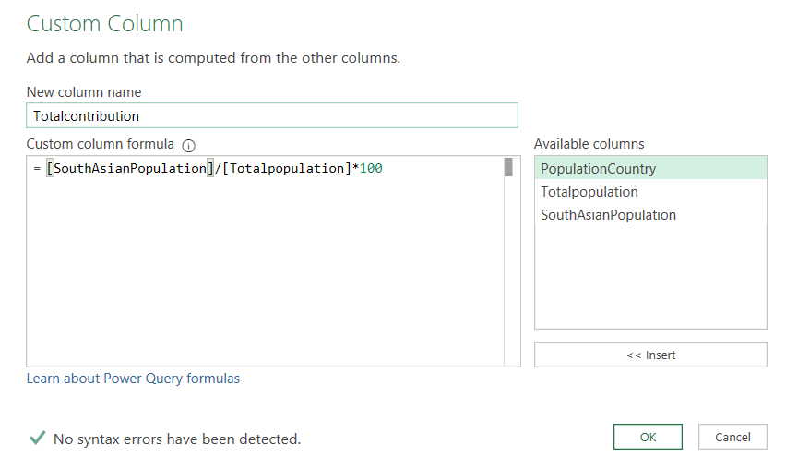



**General questions for understanding:**

1. Are countries with less population happier than those with a higher population. Take some examples and try to understand the behavior.

Simple analysis : Yes

* **Took first 50% of data ascending by population** (smallest countries)
* **Took first 50% of data descending by population** (largest countries)
* Calculated average happiness index for both groups

Supporting Evidence:

* **World Happiness Report confirms:** Countries with populations less than 15 million have **0.3 points higher** life evaluations (6% higher) on the 0-10 scale
* my data shows: **5.84 vs 5.44** average happiness index (0.4 point difference)
* Small countries make up **half of all countries** but represent much less than half of global population

Why Smaller Countries Are Happier:

* **Better governance:** Less corruption, more responsive government
* **Stronger social bonds:** Greater social support and community connections
* **Economic advantages:** Higher GDP per capita and better resource distribution
* **Quality of life:** Better healthcare access and life expectancy

1. Does higher urban population promise higher happiness? Look at some sample data.

Analysis Results:

**Countries with >50% Urban Population:**

* Average happiness: **6.0**
* Range: 3.18 to 7.73

**Countries with <50% Urban Population:**

* Average happiness: **4.47**
* Range: 1.37 to 6.7

Key Finding:

**Yes, higher urban population offers higher happiness** - countries with more urban residents score **1.53 points higher** on average in happiness ratings.

Simple Summary:

More city living = happier people overall, though individual countries can vary widely within each group.

1. Where is India standing among all these parameters? What could potentially help in increasing happiness index?

India's Position - Simple Summary with Average Comparisons

Where India Stands vs Global Averages:

* **Population:** #1 in the world (most people)
* **Population Growth:** 0.89% per year (steady increase)
* **People per area:** 492 per km² (slightly above global average of 487.6)
* **Birth Rate:** 1.94 kids per woman (below global average of 2.3)
* **Happiness Rank:** 118th out of all countries (very poor)

Key Findings:

India performs **close to average** in population density but **below average** in fertility rates, while ranking **extremely poor** in happiness despite being the world's largest population.

The Problem:

India has the most people but ranks very low in happiness - people aren't satisfied with their lives despite manageable population metrics.

How to Make People Happier:

* **Money:** Create more jobs, reduce poverty
* **Basic Needs:** Better hospitals, schools, clean water
* **Government:** Less corruption, better roads and cities
* **Environment:** Cleaner air, more parks
* **Support:** Help for mental health, stronger communities

**Bottom Line:** India's population stats are normal compared to world averages, but happiness levels are far below what they should be for such a large nation.

**There are lots of ways to solve above questions. Report any mistakes.**